Swindon Supermarine Football Club
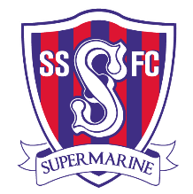
Season Ticket

APPLICATION FORM
Title: | Forename/s:
Surname:
First Line of Address:
Town: |  |  |  | Post Code:
Email Address:
Adult Season Ticket  Cost: £180 |  |  | Concession Season Ticket Cost: £100
(Please use capitals and tick the required season ticket box)

I would like to purchase a Season Ticket indicated above for the club’s league matches in the 2021/22 season. Please find my details above.

Your Signature ……….………………………………... Date ……… / ………. / …..……

Payment must be made in full by August 1st, 2021. You can pay via cheque sent with the application form via post. Or online, send the form via email and pay online, our payment details are below. Once payment is confirmed your Season Ticket will be sent to your postal address above.

Account Name: SSFC Ltd Ref: SSFC ST Sort: 404335 Account: 91535633

Please post the completed form to: Football Secretary, Swindon Supermarine FC, 16 Anderson Close, Liden, Swindon, SN3 6JW
Or email to: supermarinefc@aol.com or footballsecretary@swindonsupermarinefc.com

